Enterprise Services Development

Enterprise Security Center User Guide (Release 4.2.0)

Revision History

Date | Revision | Description | Author
09/15/2010 | 0.5 | Initial Draft | Pradeepa Arvabhumi
09/30/2010 | 1.0 | First Release | Brian J Glas
10/07/2010 | 1.0.1 | Grammatical fixes and additional content | Sheril Moffett and Brian J Glas
03/29/2011 | 1.0.2 | Added Windows Support Information for Exports | Katherine S. Adams
09/07/2011 | 1.0.3 | Added ESC Service documentation and download site URL | Fredrick Jackson
04/03/2012 | 1.0.4 | Updated ESC production URL | Rani Chode
06/07/2012 | 1.0.5 | Added documentation for custom authorizor | Fredrick Jackson
06/29/2012 | 1.0.6 | Added Managing role administration | Anu Maddipatla
02/21/2013 | 1.0.7 | Added Loss of Access | Fredrick Jackson
7/26/2013 | 1.0.8 | Added Setup Requests and Added Enhanced Role Reporting | Fredrick Jackson
1/24/2014 | 1.0.9 | Updated for Groups Changes | Craig Kelly
9/3/2014 | 1.1.0 | Updated domain data | Rani Chode

Table of Contents
1. Introduction 6
2. How to Create an Authorization Policy 6
3. Overview 7
3.1 Getting Started 7
3.2 High Level Diagram 7
3.3 Default Access 7
3.4 Environments 8
3.4.1 Development 8
3.4.2 Testing / Preproduction 8
3.4.3 Production 8
3.5 Home Tab 9
3.5.1 Symphony Profile Picker: 9
3.5.2 Application Selection 10
3.5.3 New Setup Request 10
3.5.4 New Support Request 12
3.6 Action Tab 12
3.7 Resource Tab 14
3.7.1 Sub-Resources 15
3.8 Role Tab 16
3.8.1 Application Roles 16
3.8.2 Realm Roles 16
3.8.3 Adding Groups, Users, and Applications to a Role 17
3.8.4 Adding a Group or User to a Managing Role 18
3.9 Policy Tab 19
3.9.1 Policy Rules 19
3.9.2 Extended Rules 20
3.9.3 Custom Authorizor 23
3.10 Group Tab 24
3.10.1 Prerequisites for creating a group 25
3.10.2 Creating a group 27
3.10.3 Modifying a group 28
3.10.4 Viewing a user’s groups 29
3.10.5 Deleting a group 29
3.11 Report Tab 30
3.12 Loss of Access 31
4. The Enterprise Security Service 31
Appendix A: Glossary 32
Appendix B: Troubleshooting Guide 33

Figures

Figure 1 - High Level Diagram 7
Figure 2 - Home Tab 9
Figure 3 – Symphony Profile Picker 10
Figure 4 – Application Selection 10
Figure 5 – Sign Me Up Link 11
Figure 6 Welcome Screen 11
Figure 7 Sign Me Up Modal 12
Figure 8 – New Support Request 12
Figure 9 - Action Tab 13
Figure 10 - Resource Tab 14
Figure 11 - Role Tab 16
Figure 12 - Managing a Role 17
Figure 13 - Policy Tab 19
Figure 14: Extended Rules 20
Figure 15 - Extended Rule assigned to a Rule 21
Figure 16 - Group Tab 25
Figure 17 - No Managing Role 26
Figure 18 - Group Inclusion Criteria 27
Figure 19 – Group Inclusion Criteria 27
Figure 20 – View Groups for a User 29
Figure 21 - Report Tab 30
Figure 22 – Loss of Access Flow 31

Introduction

The Enterprise Security Center (ESC) provides a web interface to allow assigned administrators to manage a role based authorization policy for an application along with LDAP group management.

The document is intended to explain the features of the Enterprise Security Center and to help lead you through the process of creating an authorization policy for an application.

There is also a computer based training (CBT) module available from the Home Tab of the Enterprise Security Center (https://sso.secure.fedex.com/esc ) that will provide a walkthrough of the basics of creating a policy.

How to Create an Authorization Policy

A policy is a collection of authorization rules for an application. A rule is a grouping of an action, resource, role, and extended rules (optional) which define what is allowed or is not allowed within an application.
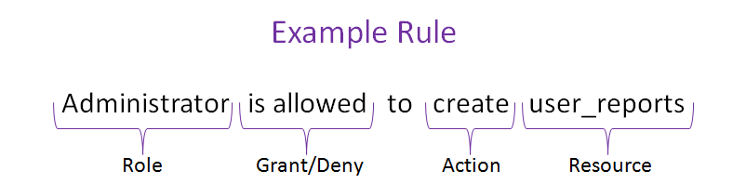

List of high level steps to create a policy:
- Determine what Actions are needed to support the business rules of the application.
- Determine the Resources that need to be protected within the application based on the business rules and functionality.
- Determine the Roles that will represent the logical groupings of users and permissions (action and resource pairs).
- Determine if Groups can be used to help create collections of users that are easier to manage.
- Determine the Rules that will be needed to map the Roles to the Action/Resource combinations.
- Determine if Extended Rules are needed to help reduce the number of Rules or ensure that as much of the Security logic as possible is represented in the Policy.

The resulting policy will need to be reviewed and understood by the development team as they will be using the isAllowed(…) method call in the code and will need to pass the correct Action and Resource in the calls (and Extended Rules if used).

Overview

Getting Started
Here is a short list of the tasks that will need to be completed to get your policy created in the ESC and enable the Security API integrated in your application to retrieve the policy.
- Make sure you have your application registered in Symphony.
- Click the “Sign me up!” link on the home page of the ESC and complete the short form.
- Request the Development Framework 4.0.0 from the EDSM Catalog or download the Development Framework 4.0.0 from the FedExtras download site: https://sso.secure.fedex.com/fedextras/downloads.iface
- Follow the instructions in Section 11.4.5 of the DevFramework User Guide to configure the Security API and request the application certificate from Information Security.
- Once you have received an email that your setup is complete, the Security API should be able to retrieve the authorization policy for use in your application.
- Training videos are located at keyword flcdirect and search for development framework

High Level Diagram
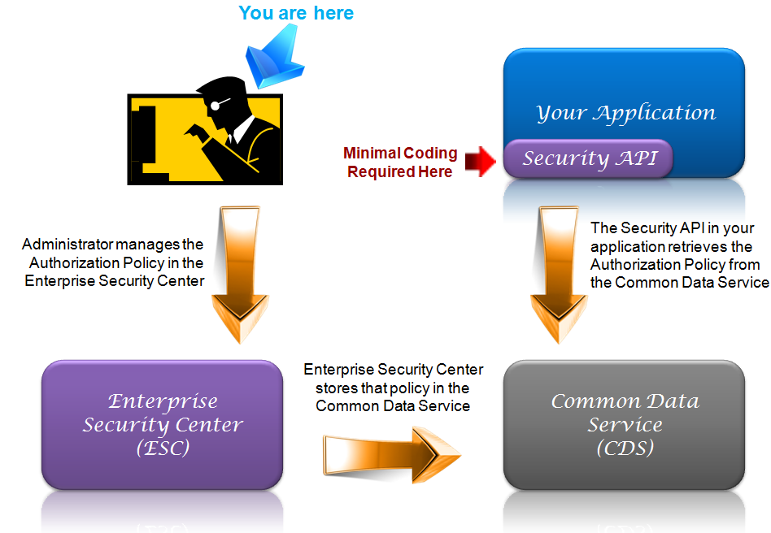
Figure 1 - High Level Diagram

Default Access
By default all users are allowed to do the following in the ESC:
- Create a self-managing role in the EA-EnterpriseSecurityCenter policy to manage LDAP groups.
- Create and manage LDAP groups.
- View your own User Access Report that shows what you are authorized to do.

Environments
The Enterprise Security Center currently has three environments to support integration of applications.

Development
The development environment is supported weekdays, 8-5 CT; and is intended for the initial application development and integration of the Security API and your application and can be found here: https://dev.secure.fedex.com/esc or keyword: devesc

Testing / Preproduction
The testing environment is supported weekdays, 8-5 CT; and is intended for use during testing activities of your application and is the last environment before production. The ESC testing environment can be found here: https://test.secure.fedex.com/esc or keyword: testesc

Production
The production environment is supported 24x7 and is available at https://sso.secure.fedex.com/esc or keyword: esc

Home Tab

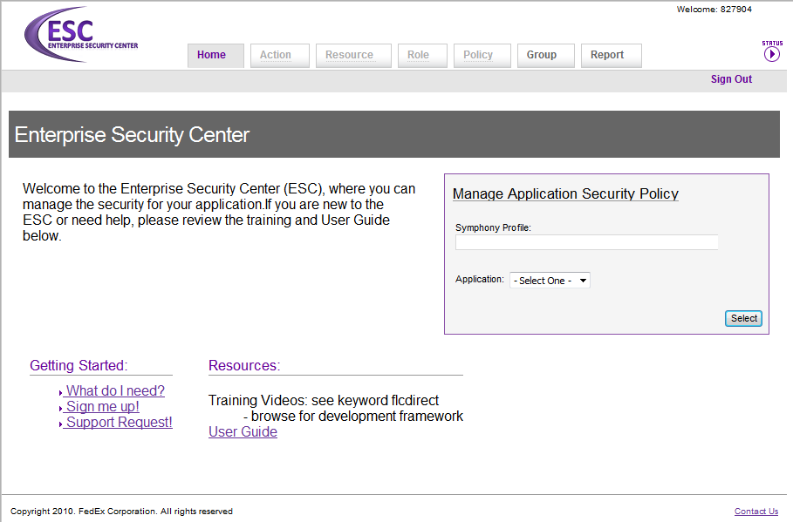
Figure 2 - Home Tab

The tabs on the home page appear according to the logged in user’s access. The tabs are the enabled by default are Home, Group and Report. A user chooses a symphony profile and application to enable the Action, Resource, Role and/or Policy tabs as authorized for the selected application.

Symphony Profile Picker:
The Symphony profile picker is an auto-complete form that allows a user to select a symphony profile from the drop down list. Type in at least single character to select a symphony profile and a drop down list will appear with a list of the first fifteen (15) available symphony profiles starting with the input character. If you don’t see what you are looking for, type more characters to reduce the number of results in the list.

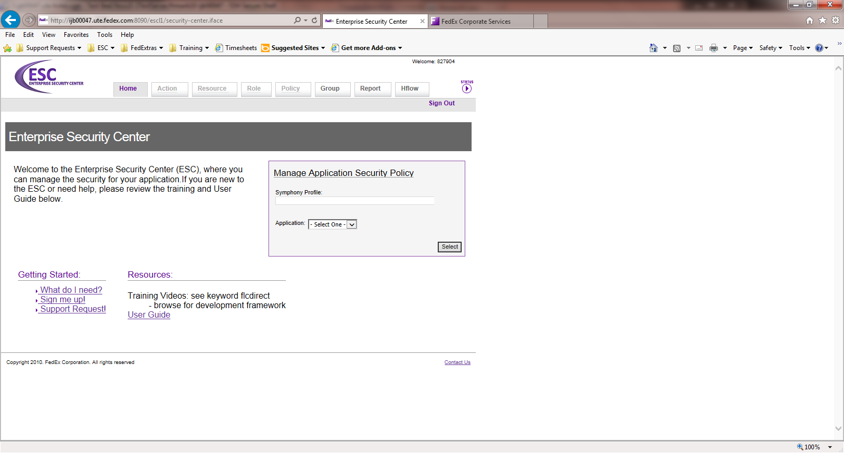
Figure 3 – Symphony Profile Picker

Application Selection
After the symphony profile is selected, the user selects an application from the drop down box. Once an application is picked, click on the “Select” button to submit the selection. If you manage multiple applications, you can return and select a new one without logging out.
Figure 4 – Application Selection

If the Symphony service is unavailable, the application drop down will change to a text box. If you know the application id that you want to manage, you can type it in and click “Select” to manage the policy.

New Setup Request
Enter new setup requests by clicking the “Sign Me Up Link” on the Home Page.

Figure 5 – Sign Me Up Link

Welcome Screen
The welcome screen displays the different esc level keywords that direct users to the desired level to submit a setup request.
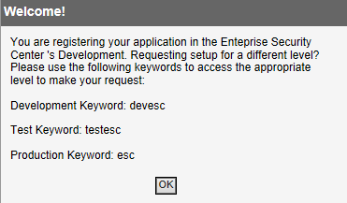
Figure 6 Welcome Screen

Registration
Select your application’s Symphony profile in the Symphony profile picker and select your application id from the application id drop down. Click the submit button and a HFLOW will be initiated by the requestor and sent to the requestor’s manager for approval. Once manager approval is received, registration will be completed within 24 hours. The automated setup process will notify the requestor via email that the setup successfully completed and to verify access in the Enterprise Security Center.

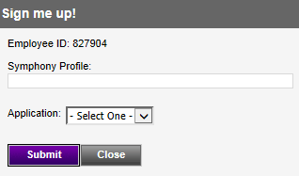
Figure 7 Sign Me Up Modal

New Support Request
Enter new support requests by clicking the “New Support Request” link on the Home Page.
Figure 8 – New Support Request

Action Tab

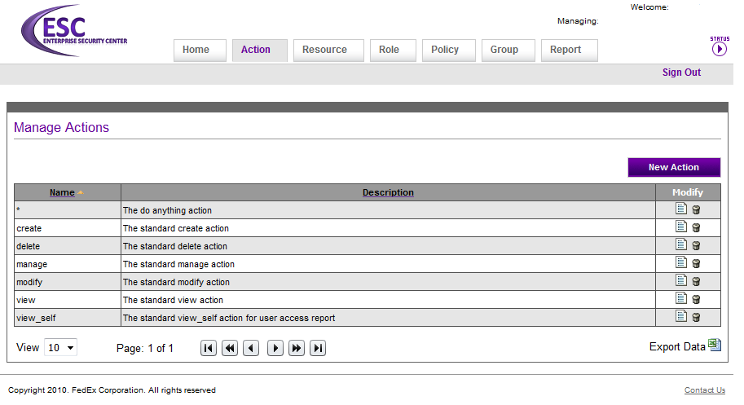
Figure 9 - Action Tab

Actions are functions applied to a resource (for example, a button or a tab on a web page). Some examples of an action would be create, read, update, delete, view, publish, modify, etc. An action may contain alphanumeric characters, underscores, or dashes. To create a rule that applies to all actions for a given resource, a single asterisk may be used for the action. When an action is deleted, any rules it was associated with will also be deleted.

Examples actions that may apply to your application are:
- Create, make, generate, build
- Read, view, access
- Update, modify, manage, edit, change, transform, adjust
- Delete, remove, cancel, erase
- Approve, reject, publish, translate, delegate

These are examples of Rules where the underlined actions are applied to the resources.
An Admin is allowed to create new sales user account.
A sales_user is not allowed to delete the reports.

Resource Tab

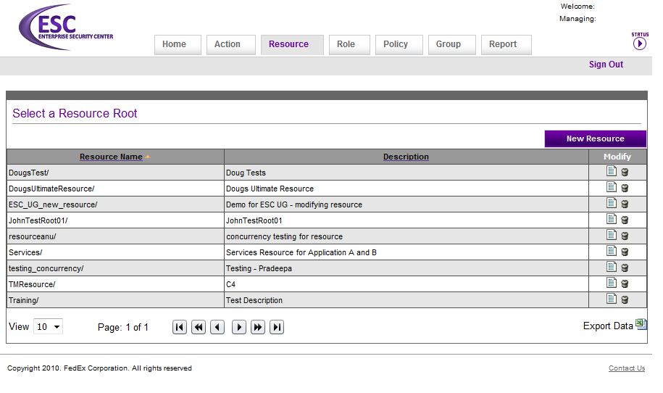
Figure 10 - Resource Tab
Resources are logical units in an application that need to be controlled. Examples of resources are buttons, tabs, data sets, reports, etc. Resources may be set up in a hierarchy. A resource may be a series of '/' delimited alphanumeric characters, underscores, or dashes, where the ‘/’ represents a hierarchy of resources. To create a rule that applies to all resources, a single asterisk may be used for resource. Also, to create a rule that applies to all resources below a given resource in the hierarchy, the resource should end with ‘/*’. Resources may only contain a “*” at the end of the resource name, it is not allowed in the beginning or middle.

Examples of Resources are underlined in the following rules.
Sales_User is allowed to read reports/sales/*.
Sales_User is allowed to create sales_accounts.

When a resource is deleted, any resources “below” it in the hierarchy and any rules associated with the resource(s) are also deleted.

Sub-Resources
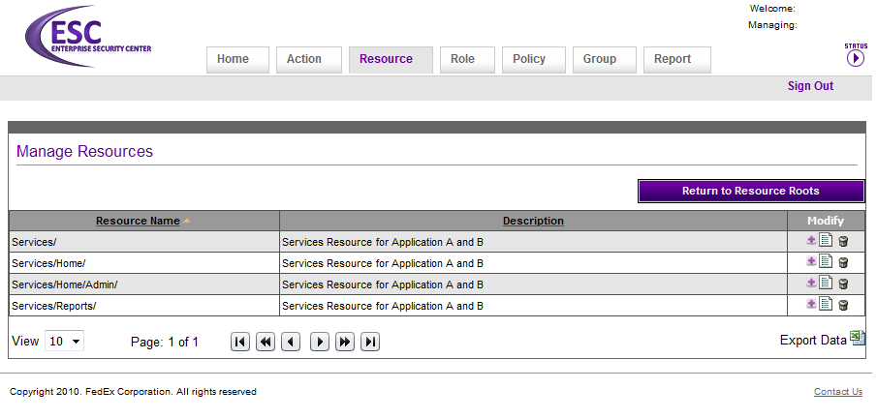
After clicking on a root resource, you will see the list of “sub-resources” that are related to the root. Resources can be placed in a multi-level hierarchy in a similar manner as a folder structure on your computer.

Services/
Services/*
Services/Home/
Services/Reports/
Services/Reports/*
Services/Reports/Annual_Report/
Services/Reports/Quarterly_Report/
Services/SupplyChain/

A wildcard (*) at the end of a resource will allow for matching all resources “below” the resource in the hierarchy. For instance if the developer sends “Services/Reports/Quarterly_Report/” to the isAllowed(…) call in the Security API, a rule with “Services/Reports/*” will match and cause the rule to be evaluated.

Role Tab
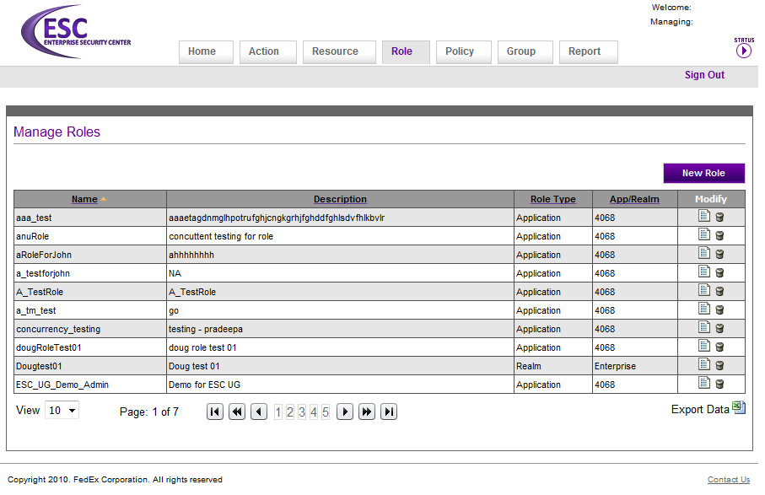
Figure 11 - Role Tab
Roles are logical groupings of individuals, application accounts, and/or groups with permissions assigned to perform particular functions within an application. Permissions are assigned to the role rather than the individual, application account, or group. Examples of roles are tester, administrator, user, etc. A role name may contain alphanumeric characters, underscores, or dashes. To create a rule that applies to all users, a single asterisk (*) may be used for role name, and users do not need to be assigned as it is understood by the Security API that it is for all users.

Examples of Roles are underlined in the following rules.
An Admin is allowed to create new sales user account.
A sales_user is not allowed to delete the reports.

Application Roles
Application Roles are unique to an application. They can only be assigned to rules that are in the policy of the same application. The majority of roles created will be specific to an application.

Realm Roles
Realm Roles can be shared across applications. They are intended to represent a collection of users that span across applications (e.g. departments: “Sales”, “Marketing”). Currently there is one Realm (Enterprise), if you have a need for another, please submit a request via the “contact us” link on the ESC.

Adding Groups, Users, Applications and Restrictions to a Role
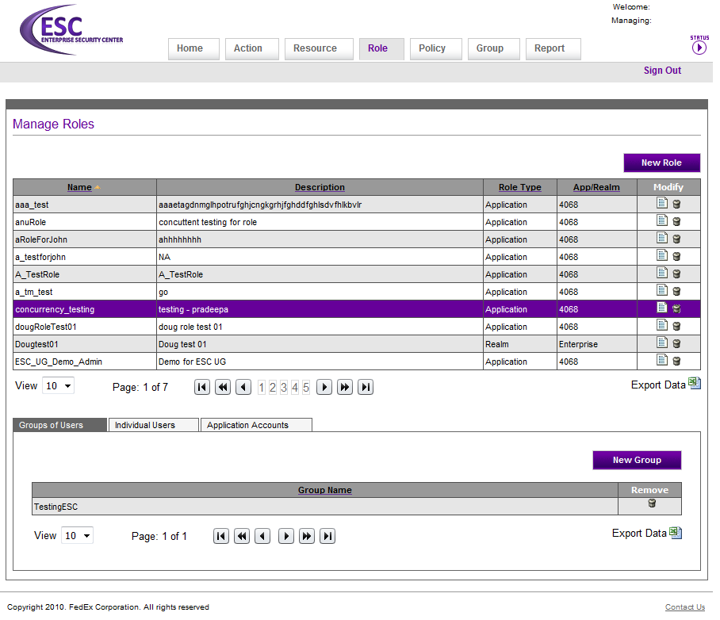
Figure 12 - Managing a Role

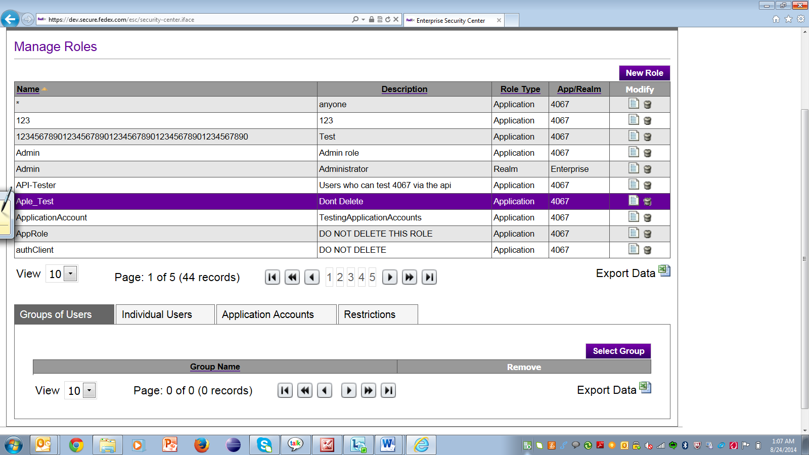

LDAP Groups, individual users (in LDAP), and/or applications (in LDAP) can be assigned as members of a Role. It is recommended to create a “dynamic” LDAP Group (Section 3.7.2) and assign the group to a role. This helps minimize the administration needed to manage the members of a role as individuals that move in and out of a specific position/job can be automatically added or removed from a role. As not all collections of users can be defined by LDAP attributes; you can also add users and applications directly to a role.

When a role is deleted, any rules associated with the role are also deleted.

Adding a role restriction to a Group or User .
The types of functions that a role can do are common for all users/groups, by adding a restriction at user or group level access can be restricted based on certain condition. Security API supports role restrictions for ESC based applications.
Pricing Analyst role has the same job functions and authorizations irrespective of working on pricing proposals for EMEA and LAC, so without creating two different roles we can achieve this by adding a restriction to groups.
Example use case :
Assume there exist Group-A of Pricing Analysts (Role) and Group-B of Pricing Analysts (Role).
Group-A works on pricing proposals for EMEA only.

Group-B works on pricing proposals for LAC only.

Group-A and Group-B are physically located outside of EMEA and LAC.
Create a role pricingAnalyst.
Create two groups pricingAnalyst_EMEA and pricingAnalyst_LAC and add these two groups to pricingAnalyst role.
Add a restriction region = EMEA to group pricingAnalyst_EMEA.
Add a restriction region = LAC to group pricingAnalyst_LAC.
Create a rule pricingAnalyst is allowed to work on proposals.
.
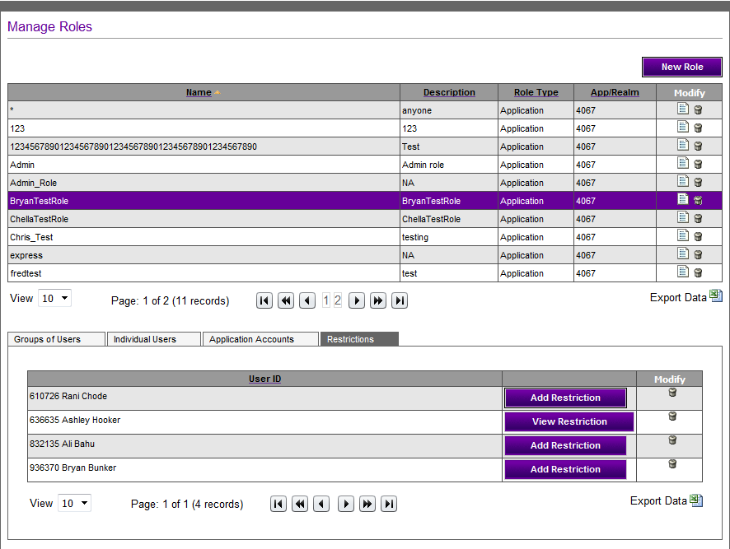

Add Restriction

The Restriction tab will show all individual users and groups that are associated with the selected role. Admins can add restrictions by selecting the “Add restriction” button or view and modify restrictions by selecting the “view restriction” button.
Only one restriction can be added for a given application ID, role name, and user ID/group combination. Each restriction can have multiple restriction data items and each restriction data item can have multiple Entry objects. Each restriction item is an “or” condition and all Entries within the restriction data item are “and” conditions.
To add a restriction follow the steps below
- Click on ‘Add restriction’ button and then ‘NewRestriction DataItem’ button.
- 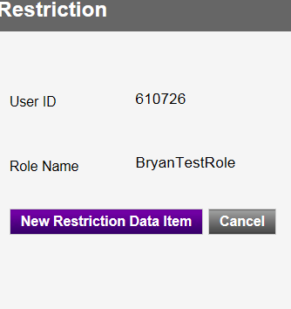
- Add a key and value(s) entry to the restriction data item.(Multiple key value pairs can added and they will be evaluated as ‘AND’ condition).
- A single key can have multiple values (key: opco value:services, Express)

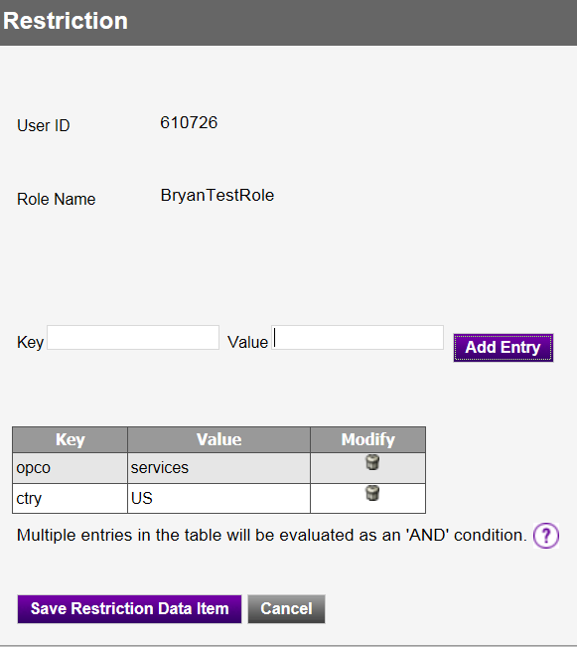
- Click on ‘Save restriction Data Item’ and click on ‘Save Restriction’.(Multiple Restriction Data items can be added and they will be evaluated as or condition).
- 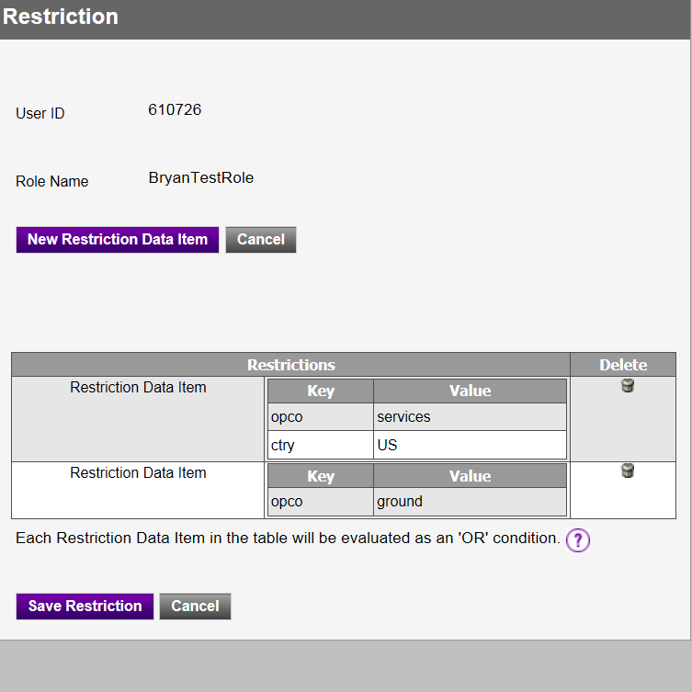
.

Adding a Group or User to a Managing Role
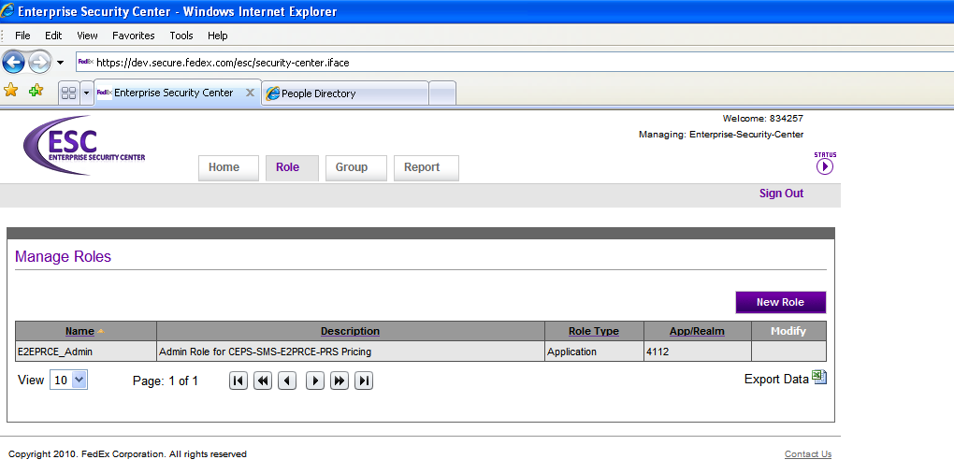

If you are already a member of a managing role you will be able to add more users/groups to the managing role by clicking on the “Home” tab, typing in the Symphony profile “EA-EnterpriseSecurityCenter” and selecting the “4112 – EnterpriseSecurityCenter” application. A Role tab will appear. Click on the Role tab and you will see a managing role for your application. Add users/groups to that role. The members in the managing role have access to the Enterprise Security-GUI and will be able to make changes to the authorization policy. (Note: It may take up to 5 minutes for the policy in the ESC to refresh the membership of the new role.).

Policy Tab

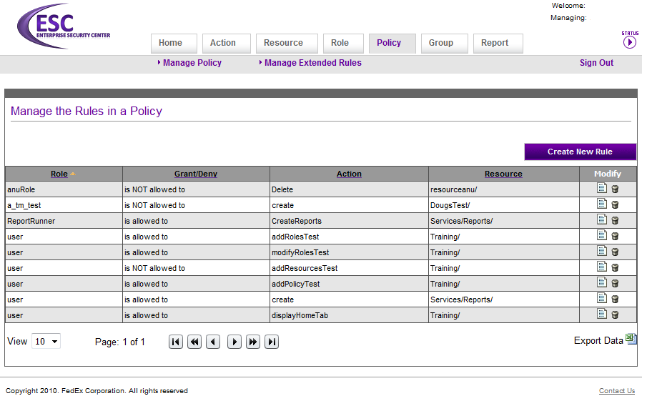
Figure 13 - Policy Tab

A Policy is a collection of authorization rules for an application.

A Rule is a grouping of an action, resource, role, and extended rules (optional) which define what is allowed or is not allowed within an application.

Policy Rules
The ESC supports explicit deny rules in the centrally managed policy implementation. The patterns of “default deny” and “deny overrides” are followed. The order of evaluation is listed below:
  - DENY rules are evaluated, if there is a match, isAllowed(…) returns false.
  - GRANT rules are evaluated, if there is a match, isAllowed(…) returns true.
  - If no rules are found for the action/resource pair, isAllowed(…) returns false.

Examples of Rules:
Admin is allowed to create new sales user account.
Sales_User is not allowed to delete the reports.
Sales_User is allowed to read reports.

Extended Rules
Extended rules are intended to provide a way to customize a rule by adding something similar to an SQL “where” clause. This should help in a number of cases to reduce the total number of resources and expand the usefulness of the “default” rules. One or more extended rules may be attached to a rule, all must evaluate true/positive (“and”) for isAllowed(…) to return true.

Name – is supposed to match a key (String) in the map that is passed to isAllowed.

Operator – indicates what type of operation to perform on the value matched to the key in the map

Value – the value that is to be compared against the value matched to the key in the map

Value Type – indicates what to cast the value as for comparison. The special value type of “Key” is to be treated as a String and searched for in the map as a key. The values of the two keys will be compared against each other by their default/defined comparator.

(For more details and code examples, please read the Development Framework User Guide.)

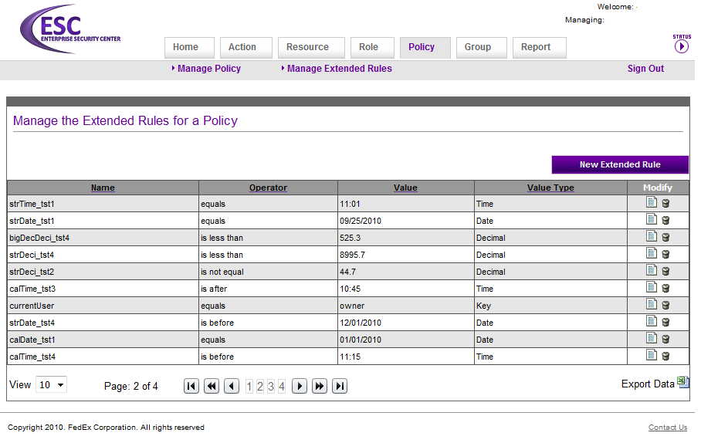
Figure 14: Extended Rules

Assigning Extended Rules to a Rule
To assign an extended rule to a rule, click on the rule and the extended rules section will open below the rules. Click on the “Add Extended Rule” button and select an extended rule to add to the rule.

(If you delete an extended rule, it will be removed from any rules that the extended rule is associated with.)

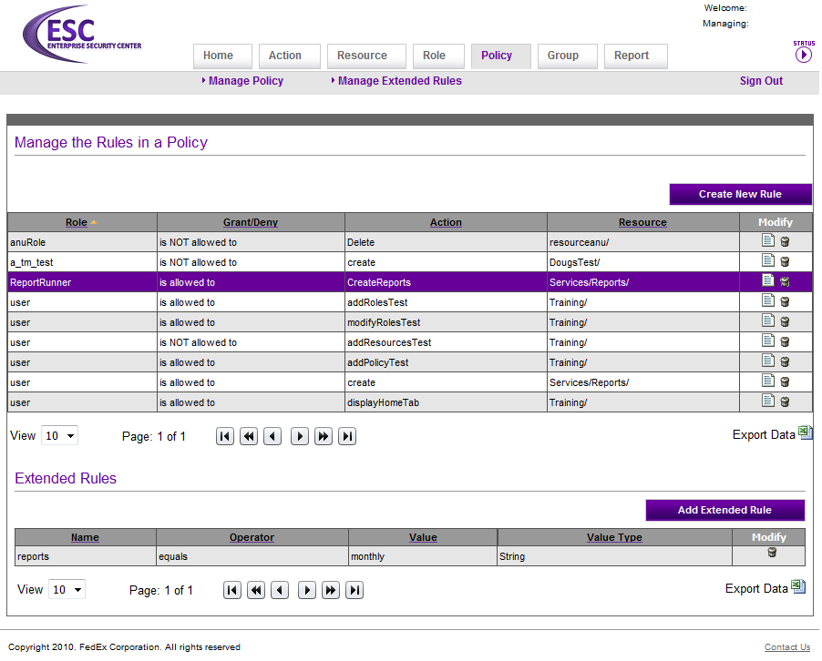
Figure 15 - Extended Rule assigned to a Rule

Supported Operators and Value Types
There are several combinations of operators and value types supported, please review the chart below:

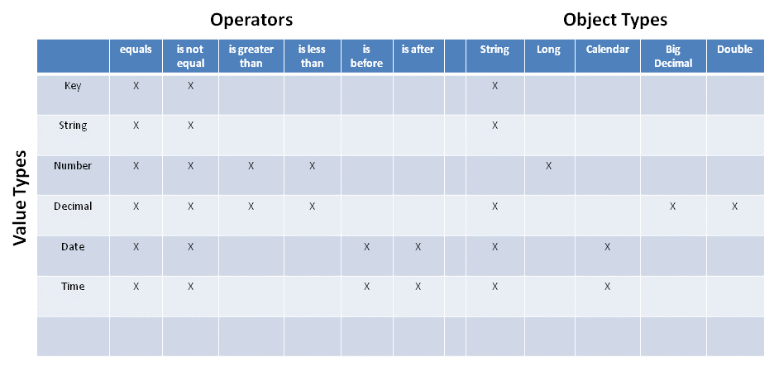

Value Types are selected when the rule is created in the Enterprise Security Center.
Object Types are the supported Java objects for the corresponding Value Type.

For example, if you look at the “Date” value type, you can tell that as a developer you can pass either a String representation (MM/dd/yyyy) or a Calendar object in the Map to isAllowed(…). The valid operators that can be configured for a “Date” value type are equals, is not equal, is before, and is after.

The operator “is greater than” is the same as “is after”. The operator “is less than” is equivalent to “is before”. One of the goals of the Enterprise Security Center is to try and use less technical terms where possible. It is clearer to have “currentDate is after 10/31/2010” rather than “currentDate is greater than 10/31/2010”.

Custom Authorizor
Custom Authorizers are intended to extend authorization of the Security API’s authorization. A custom authorizer is defined when you want to do your own domain specific checks for your application.
A good example would be a courier who is assigned to work on 5 dispatch workstation per day and you want to check his assignment to workstation. ESC authorizer will make a check to see if the courier is in the role but you also want to check his workstation that he is authorized so you extend the standard authorizer and make the second level check.

Class –
The name of the custom authorizer is the entire package name along with the class name.

Description –
A brief description of the authorizer class describing what it does.

You can define multiple custom authorizers for your application but only one of them can be associated with a rule. To define custom authorizers for your application click on Policy tab and on Manage
Custom Authorizer Link.

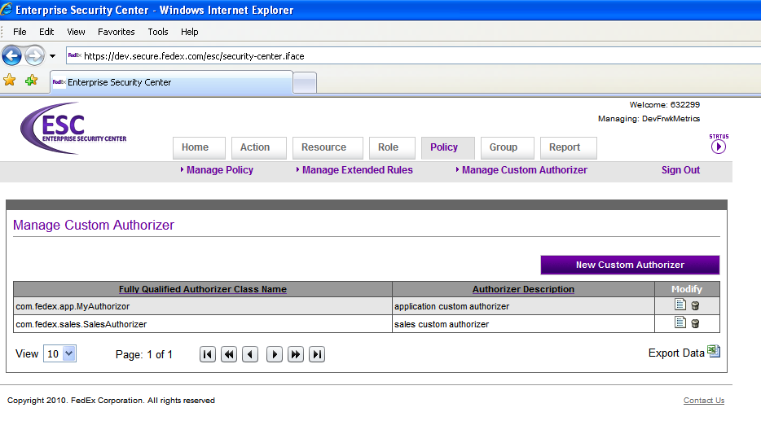

Assigning a Custom Authorizor to a Policy
To assign a custom authorizor to a rule, click on the rule and custom authorizor section will open below the rules. Click on the “Add Customer Authorizor” button and select a custom authorizor to add to the rule. Only one custom authorizor can be associated with a policy.

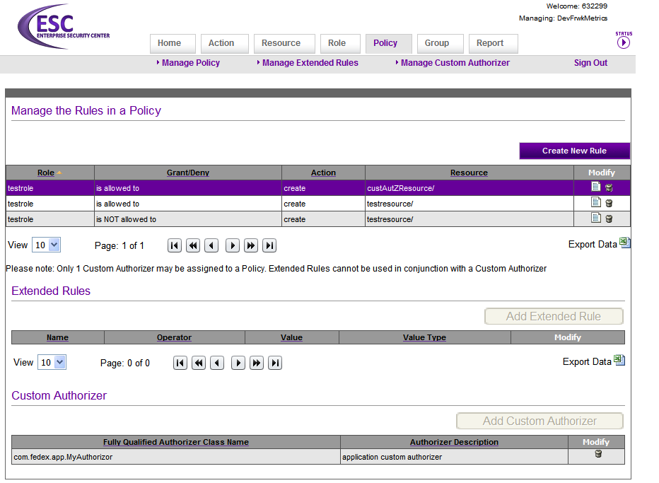
(If you delete a custom authorizer, it will be removed from any rules that the custom authorizer is associated with.)

Policy Data
Policy Data is a collection of actions, resources, roles, policies and the groups assigned to the role. Users can now download all of their data to an excel sheet. The policy data link under the role tab will navigate users to a page where the excel sheet can be downloaded.

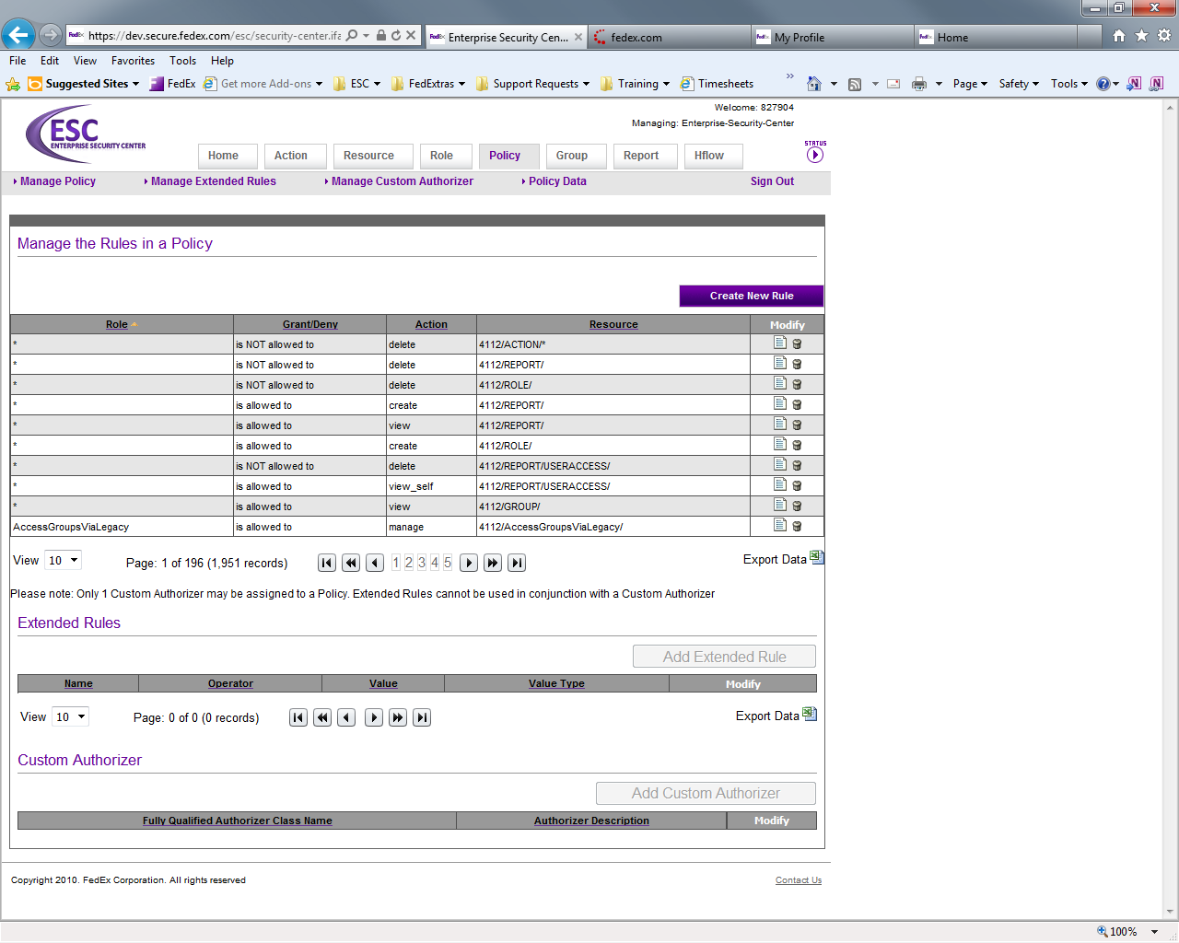

When clicking the export button a popup will appear that displays a link to download the spreadsheet.
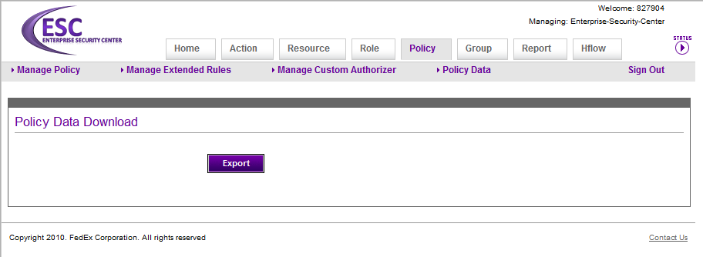

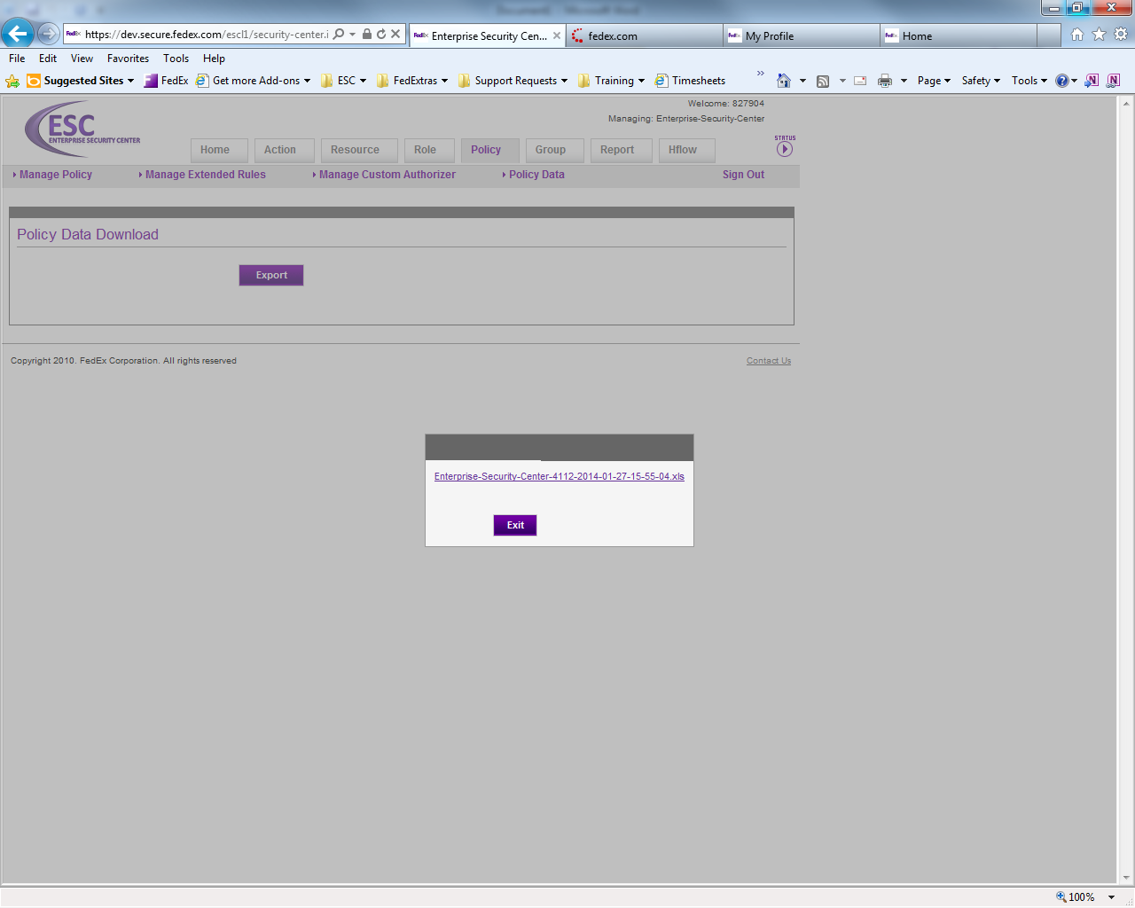

Group Tab
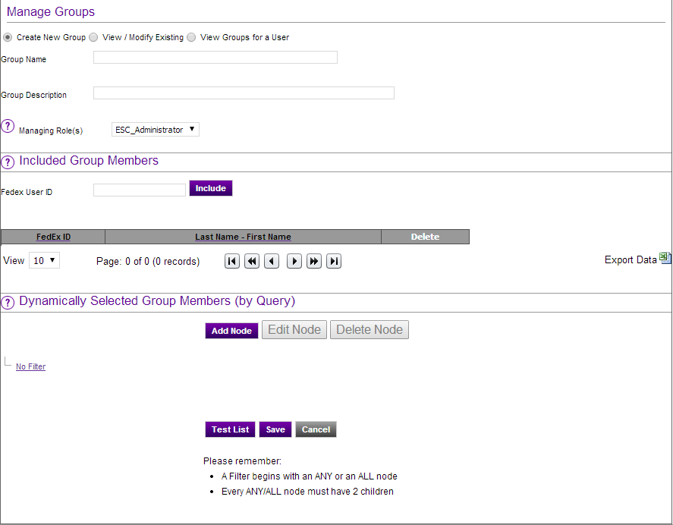
Figure 16 - Group Tab

A group is defined as a logical grouping of people defined by common LDAP attributes or FedEx ID. Group definitions are stored in LDAP. In the ESC, a managing role is authorized to modify a particular group. A managing role could be authorized to modify one group or many groups. Any group created in the ESC is assigned a managing role. If you have any groups that already exist and you would like to manage them in the ESC, please click the “contact us” link on the lower right hand side of the screen and send in a detailed support request.

Prerequisites for creating a group
If you have never created a group and/or are not already a member of a managing role, you will need to create a managing role before creating a group. A message will be displayed on the group tab to this effect if you attempt to create a group and are not a member of a managing role. You can create a managing role by clicking on the “Home” tab, typing in the Symphony profile “EA-EnterpriseSecurityCenter” and selecting the “4112 – EnterpriseSecurityCenter” application. A Role tab will appear. Click on the Role tab and create a new role to use for managing a group. You will be automatically added to the new role as a member and any member of the role is authorized to modify the membership of the role. (Note: It may take up to 5 minutes for the policy in the ESC to refresh with the new authorization to modify the membership of the new role.)

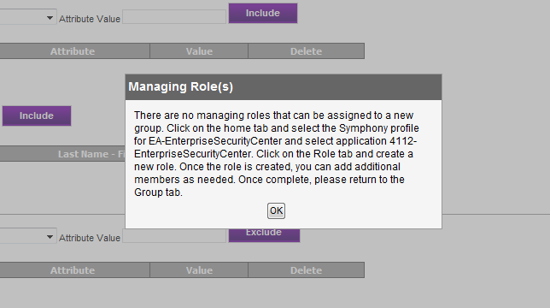
Figure 17 - No Managing Role

Creating a group
Anyone is allowed to create a group. They just need to be a member of a managing role as mentioned above. Dynamic groups are recommended whenever possible.

Included Group Members
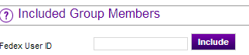
Figure 18 - Group Inclusion Criteria

Included Group Members (also known as “static” members) are FedEx ID’s that are manually added to the group. For convenience you may enter a comma-delimited list of multiple ID’s to add several ID’s at the same time.

Dynamically Selected Group Members
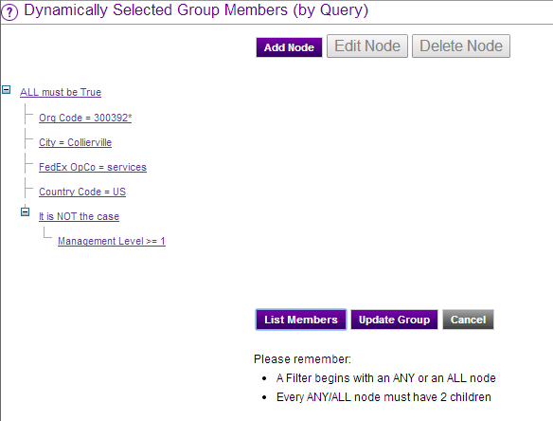
Figure 19 – Group Inclusion Criteria

You may supply LDAP attributes in the form of a query to specify group members dynamically. As a result, changes to a person’s LDAP record can move them in to or out of your group. For instance, if a group is defined by an Org Code, when someone joins the group they will be automatically added as a member of the group. The current supported LDAP attributes are:
- Org Code
- Job Code
- Management Level
- Station
- City
- Country Code
- Sales Territory ID
- FedEx OpCo
- FedEx Express Region
- FedEx User ID
In addition, you may specify a “custom” attribute. Please note that custom attributes require that you know the exact LDAP attribute name and what value to specify. (For example, if you use the attribute NSRoleDN, you will need to specify the complete Distinguished Name for the role).
Queries are actually “trees” that allow you to construct nested queries of LDAP attributes. (Advanced LDAP users will recognize this as a convenient wrapper around LDAP filters). You may create a query that requires a series of criteria to be true by using the ALL node. (An ALL node requires that all of its children are true.) You may also create a query that requires only one of many criteria to be true by using the ANY node. (An ANY node requires only one of its children to be true.)
The example in Figure 19 above uses an ALL node. As a result, people who match all five of the criteria will be added to the group. In this case:
- People whose Org Code begins with 300392 (which as of Jan 24th 2014 is everyone in Michelle Epps’s organization)
- People domiciled in Collierville
- People who work for FedEx Services
- People domiciled in the United States
- People who do NOT have a Management Level >=1 (so only Individual Contributors)
Please note the use of NOT with Management Level. You may use the NOT checkbox to exclude people by attribute (instead of the default action of including by default).

Modifying a group
Modifying a group is very similar to creating a group, but you must be a member of the managing role to be authorized to modify the group. If you are not, the system will alert you that you are not authorized to modify the group. Clicking “List Members” on the view/modify group page will show the members based on the current group definition on the screen.

Viewing a user’s groups
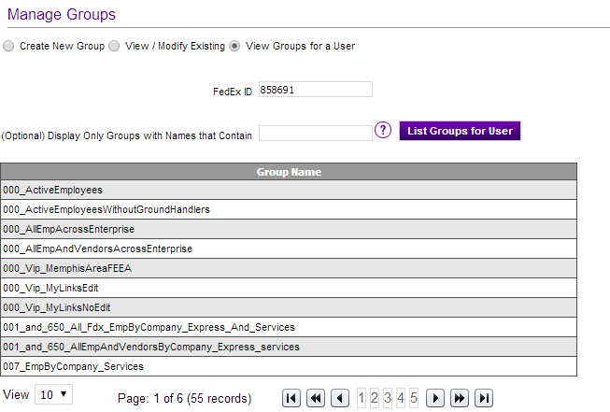
Figure 20 – View Groups for a User
You may view all the groups that user currently belongs to. After selecting “View Groups for User”, enter a FedEx ID and click the “List Groups for User” button. You may choose to display only the groups whose names contain a particular string by entering your criteria in the box labeled “Display Only Groups with Names that Contain”.
Please note that these groups are displayed by querying GRS, the LDAP caching application. As a result, changes made to a group may not be immediately reflected on this page.

Deleting a group
At this time there is no support for deleting a group. If a group deletion is required, please contact LDAP by opening an RT request at https://request.fedex.com and queue is ldap.

Report Tab

Reports detail the audit trail for the application that the logged in user is managing, user access of the logged in user based on the dates provided or a detailed report for role assignments.

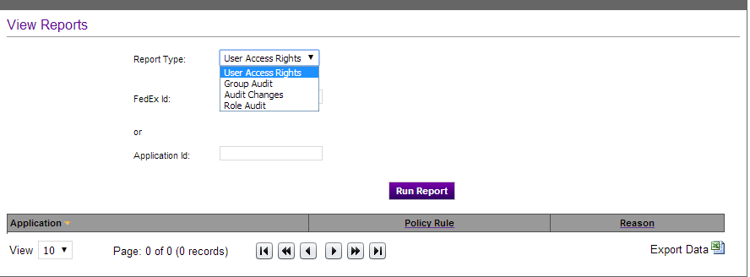
Figure 21 - Report Tab

There are four types of reports:
- A list of access rights for a given user
- A list of changes made to a particular group
- An audit trail of changes to an application policy
- An audit trail of role assignments
Each user is authorized to view their individual access report. An administrator of an application can be authorized to view the audit report of changes for the application’s authorization policy and role audit report.

Loss of Access
GRS publishes a message to their JMS Queue when a user is removed from a group in LDAP via a group update from ESC or Human Resources related event. ESC consumes the message from JMS Queue and determines what roles were affected. ESC will then publish a message to its JMS Topic and create an audit record reporting what roles the user loss access to. Also, ESC will publish a JMS message and create an audit report when a user is removed from a role within ESC.

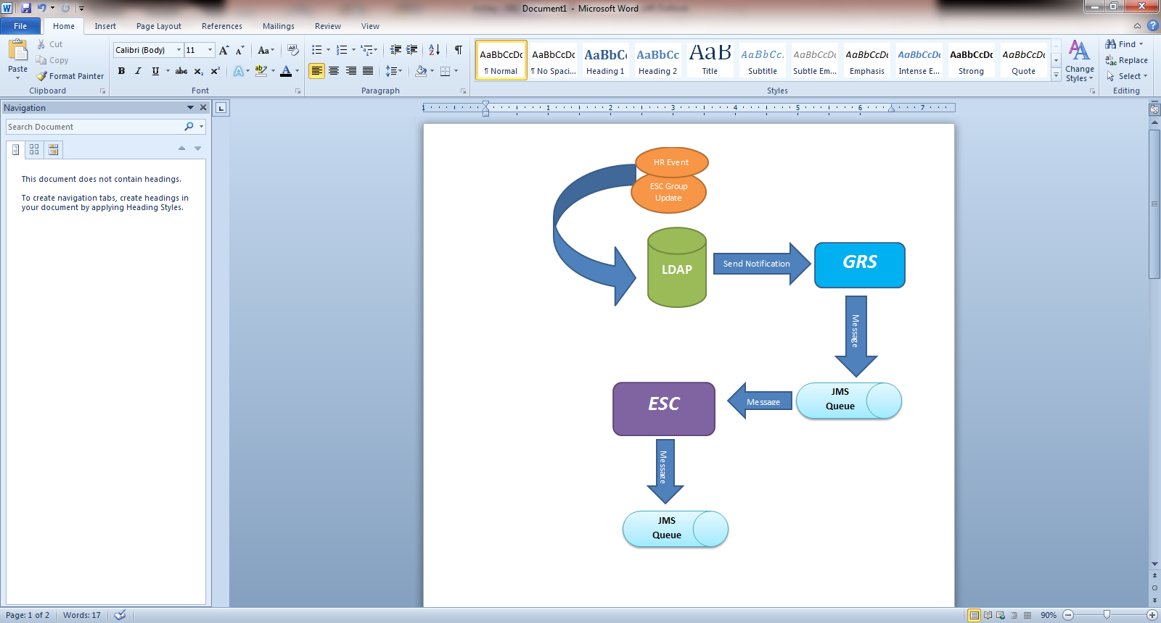

Figure 22 – Loss of Access Flow

The Enterprise Security Service

The Enterprise Security Service is a Common Service Runtime (CSR) enabled web service that will allow developers to programmatically insert actions, resources, roles, policies into CDS. User documentation for the Enterprise Security Service can be found at http://itg.prod.fedex.com/sf/go/doc483104?nav=1

Appendix A: Glossary

Term | Definition
Action | An application logic provided operation
Authentication | The means by which an identity is validated to be that which it claims to be.
Authorization | The means by which a validated identity is evaluated against the actual access decisions needed, based on the "permissions" or "roles" are associated with the identity in question.
Authorizor | An interface defined by the API that provides an object with methods to invoke to perform authorization, the method specifically is called "isAllowed()".
Identity | Something that uniquely names an individual or other entity like an application or a machine.
LDAP | Lightweight Directory Access Protocol, also used frequently around FedEx (and in this document) to refer to the contents of the people directory, which include identities for people as well as applications.
Permission | An action combined with a resource that it applies to.
RBAC | (Role Based Access Control) This is the type of security system implemented the API. In this type of system, the decisions to allow or not allow access are based on the "roles" a given identity possesses.
Resource | A named part of the application that can be "acted" upon by some number of "actions" defined by the application logic.
Role | A collection or grouping of identities defined either by a comma delimited list, or an LDAP group.
Rule | A mapping of role to a resource and action (with optional inclusion of a custom authorizor) that specifies the role membership required to be allowed to perform the action on the given resource.
CSR | Common Service Runtime is a Framework component that will allow developers to create framework enabled web service

Appendix B: Troubleshooting Guide
ITEM # | ISSUE | RESOLUTION
1. | Excel won’t launch when I click the Export icon on one of the ESC pages. | Windows XP Solution:  - Open Control Panel  - Open Folder Options  - Click File Types  - Locate "XLS Microsoft Excel Worksheet" -- Quickly scroll to items beginning with 'X' by pressing the 'X' key on the keyboard.  - Click the Advanced button.  - Highlight the default action (often Open), which is bold.  - Check the box that says "Confirm open after download" and if "Browse in the same window" i0073 checked, uncheck it.  - Click Ok.  Users on Vista, Windows 7, or an operating system other than XP, will have to research a solution for their environment. This is technically not an ESC issue – it is a desktop issue.

